Experiment 4: Operational Amplifier Application: Electronic Security System

Design: Part 1 of 2

By:

Shawn Keene, Jason Gilman

Supervisor: Saad Muaddi

Data collected on: 10/09/2019

Due: 10/23/2019

ECEN 214-508, Electrical Circuit Theory

Fall 2019

Prof. Scott Miller

**Introduction:**

The purpose of this experiment was to demonstrate an understanding of op amps, IR emitters, photo detectors, and their practical uses in the real world. An OP amp is a circuit that can be manipulated by adding different components to the inputs and outputs in order to make it perform various mathematical operations. For this lab an inverting, non-inverting and comparator OP amp will be used. Comparators compare different voltages and operate at saturation when the input voltages are not equal. Once these topics are learned, students will combine each unit together in lab 5.

**Procedure:**

Task 1 of the experiment involved building simple circuits for both the IR emitter and photodetector. A resistor was connected to both the emitter and detector each serving a different purpose. Voltage on the emitter and resistor was then measured for different resistor values varying from 1000Ω to 360000Ω. After the voltage values for different resistors were obtained, the experiment was repeated but on the photodetector. The voltage was measured on the detector for two different cases; obstructed and unobstructed. Where bstructed was obtained by putting an object in between the emitter and detector, and unobstructed was obtained by leaving the emitter and detector how they were.

Task 2 involved building an inverting and non inverting amplifier and connecting the correlating input for each to the vcc. After the amplifier was made, the vcc was connected to the negative or inverting terminal. The output terminal was then measured for different input voltage values ranging from -5V to 5V. After the values of the inverting amplifier were obtained the vcc was switched to the positive terminal in order to create a non-inverting amplifier. The task was then repeated.

Task 3 began by building a comparator. This involved choosing two resistors to bring the voltage down to a good level to compare to. After the resistors were chosen and the comparator was built, several values of V were tested in order to compare the calculated reference voltage with the real reference voltage.

**Data:**

Task 1:

Emitter

|  |  |  |
| --- | --- | --- |
| $R_{E}$ (Ω) | $V_{Resistor}$ (V) | $V_{Emitter}$ (V) |
| 2000 | 3.855 | 1.136 |
| 1000 | 3.829 | 1.162 |
| 5100 | 3.892 | 1.101 |
| 2200 | 3.860 | 1.133 |
| 3300 | 3.876 | 1.117 |
| 10000 | 3.918 | 1.075 |
| 360000 | 4.081 | 0.910 |

Detector

|  |  |  |
| --- | --- | --- |
| $R_{D}$ (Ω) | $V_{D - Unobstructed}$ (V) | $V_{D - Obstructed}$ (V) |
| 2000 | 4.844 | 0.082 |
| 1000 | 4.684 | 0.030 |
| 5100 | 4.890 | 0.109 |
| 2200 | 4.847 | 0.051 |
| 3300 | 4.873 | 0.095 |
| 10000 | 4.911 | 0.169 |
| 360000 | 4.769 | 3.149 |

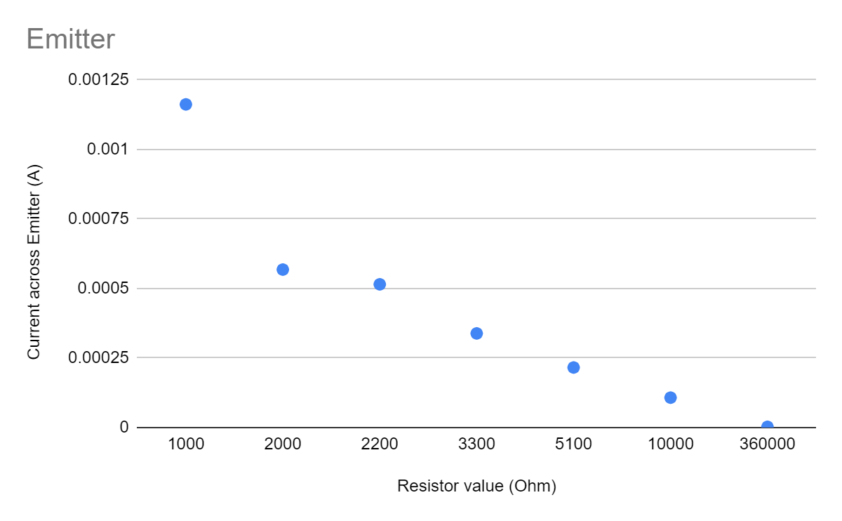

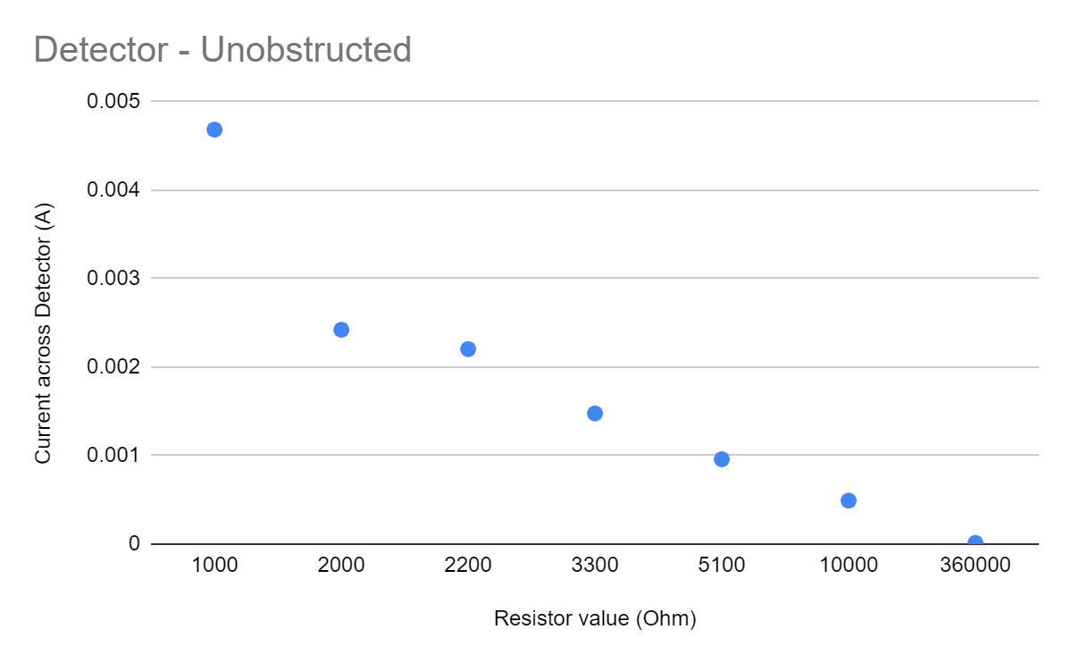

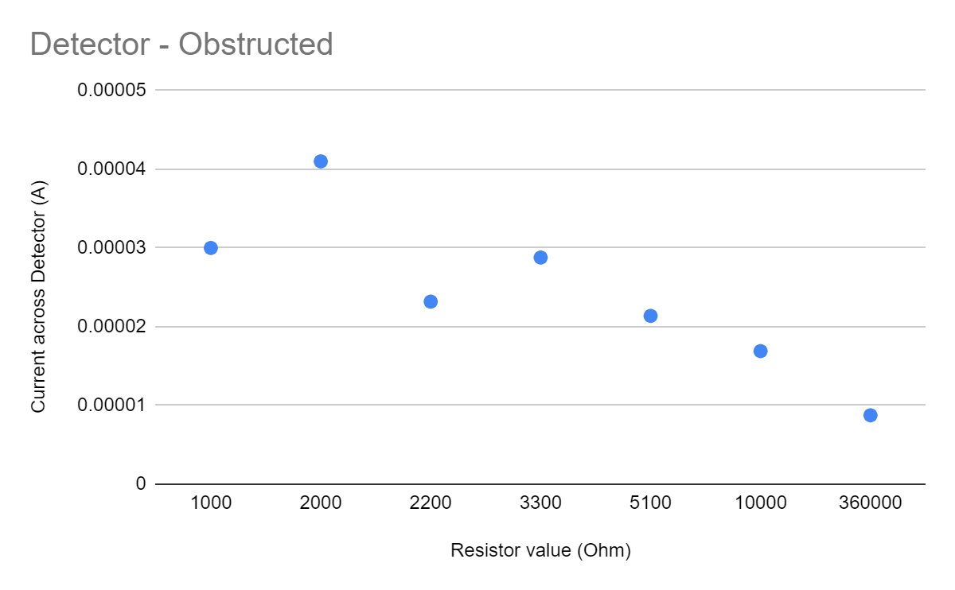

Op-Amp combined with Detector:

$R_{D}=1000$ Ω $V_{D}= -3.879$ V

Task 2:

For inverting Amplifier: $R_{1}=1000 Ω$ $R_{2}=1000 Ω$

For non inverting Amplifier: $R_{1}=360000 Ω$ $R_{2}=1000 Ω$

Saturation: -5 <= x <= 5

|  |  |  |
| --- | --- | --- |
| $V_{in}$ (V) | $V_{out - inverting}$ (V) | $V_{out - non-inverting}$ (V) |
| -5 | 3.509 | -4.924 |
| -4.5 | 3.510 | -4.525 |
| -4 | 3.522 | -4.025 |
| -3.5 | 3.521 | -3.52 |
| -3 | 3.04 | -3.016 |
| -2.5 | 2.537 | -2.518 |
| -2 | 2.033 | -2.017 |
| -1.5 | 1.529 | -1.517 |
| -1 | 1.022 | -1.013 |
| -.5 | .515 | -.509 |
| .5 | -.497 | .497 |
| 1 | -1.005 | 1.001 |
| 1.5 | -1.51 | 1.505 |
| 2 | -2.014 | 2.005 |
| 2.5 | -2.521 | 2.506 |
| 3 | -3.027 | 3.008 |
| 3.5 | -3.532 | 3.512 |
| 4 | -4.039 | 3.703 |
| 4.5 | -4.061 | 3.704 |
| 5 | -4.05 | 3.703 |

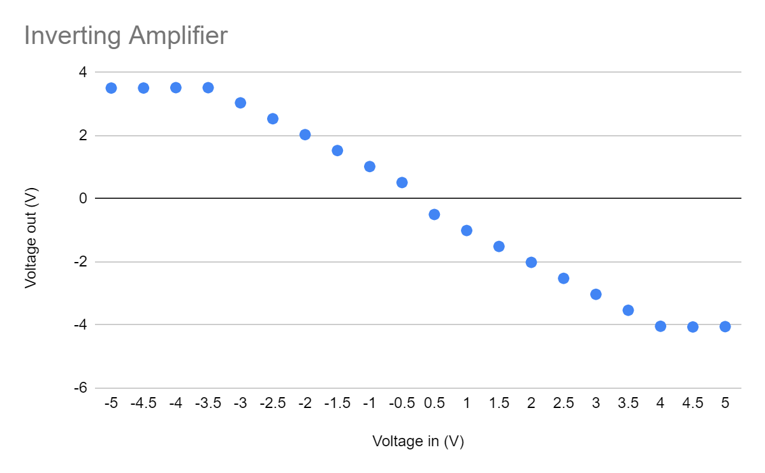

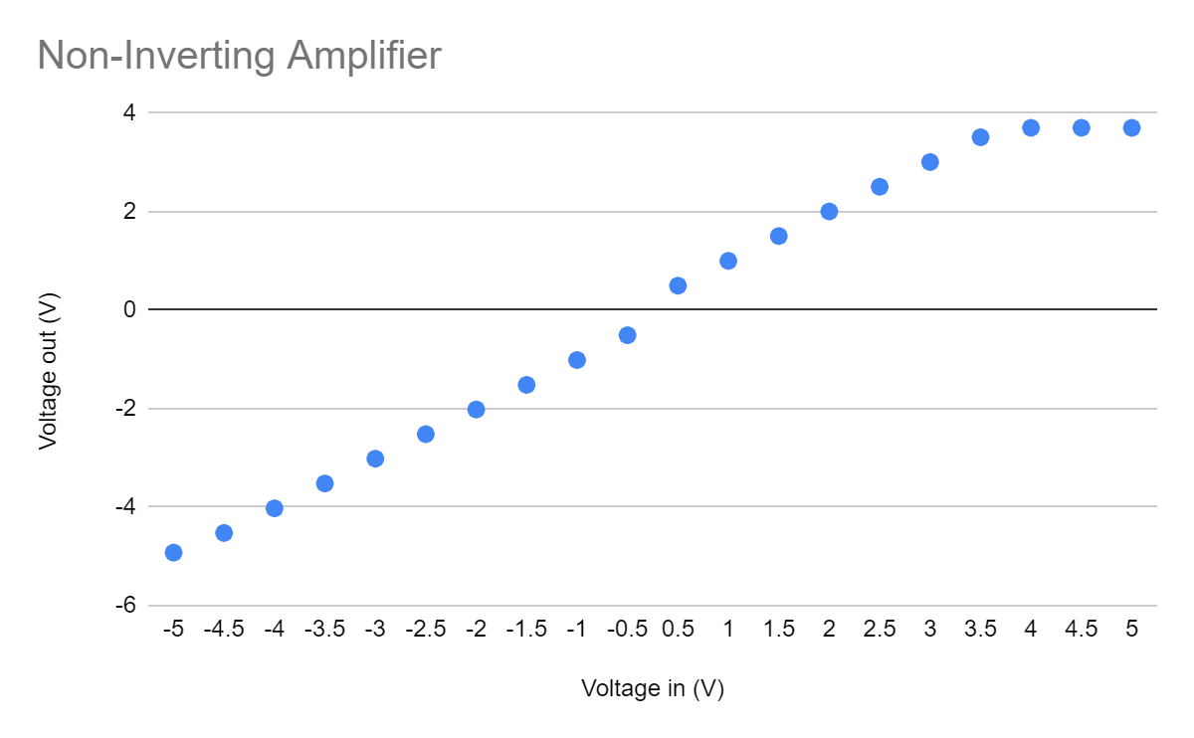

Task 3:

$R_{1}=1000 Ω$ $R_{2}=1000 Ω$

Comparator

|  |  |
| --- | --- |
| $V_{in}$ (V) | $V_{out}$ (V) |
| 0 | 4.958 |
| .5 | 4.958 |
| 1 | 4.958 |
| 1.5 | 4.958 |
| 2 | 4.958 |
| 2.5 | 4.958 |
| 3 | .173 |
| 3.5 | .174 |
| 4 | .175 |
| 4.5 | .175 |
| 5 | .178 |

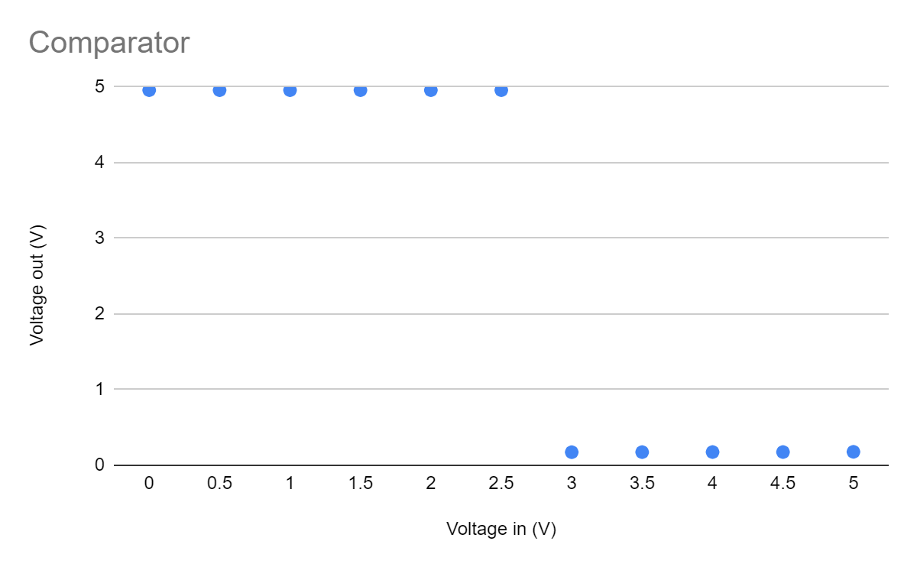

**Calculations:**

For task 2, to calculate the gain, the following equations were used:

$G_{inverting}= -R_{2}/R_{1}$ $G_{non-inverting}=1+R_{2}/R_{1}$

In order to get a gain of around 1, these resistor values were used:

$R_{1}=1000 Ω$ $R_{2}=1000 Ω$

For the non inverting amplifier, we used resistor values of:

$R_{1}=360000 Ω$ $R_{2}=1000 Ω$

**Discussion:**

For task 1 we decided to choose a 1000 ohm resistor. The photo detector resistor converts current into voltage, so in order to get the lowest voltage when the emitter is obstructed a low ohm resistor is wanted. This in turn correlates to the highest difference between unobstructed voltage and obstructed voltage which was 4.654 volts. Along with this, the photo detector worked correctly whenever it was placed within 6 inches of the emitter and incorrectly if it was placed more than 6 inches away. Next the photodetector was connected to an op amp which turns out to be better than a resistor. This is because if an output voltage is too high, the saturation from the op amp will keep it well within its limits.

Two types of op amps were built in task 2, an inverting one and a non-inverting one. Each type of op amp required different resistor values. For the inverting op amp, equal low resistances of 1000 ohms were chosen in order to get the greatest difference and a voltage gain of one. For the non-inverting output, one extremely high ohm resistor was chosen with one low ohm resistor. The intention of this was to bring the gain down to as close to one as it could possibly get. In this case the gain was 1.0734 volts.It was decided that a non-inverting op amp would be better for the detector/comparator because the input(photodetector) can have the lowest resistance in the positive terminal and it does not complicate the comparator due to not having to deal with a negative value.

In the previous task, the voltage from the non inverting amplifier was obtained. The maximum voltage that was possible through the non inverting amplifier was 3.7 volts. For simplicity sake the vref in the comparator will be 2.5, as that provides a good buffer and does not make the detector overly sensitive. In order to do this, two resistors of equal value were placed on the breadboard with the input into the comparator being the voltage between the two resistors. This can be calculated with the voltage divider rule which in this case would become 5*½ or 2.5. In order to get the desired outputs, the photodetector would be plugged into the positive terminal and a constant voltage below 3.7 would be provided into the negative terminal. If the positive terminal is above the negative terminal, the comparator will output a high value, and if it is below the negative terminal it will output a low value.

**Screen Shots:**

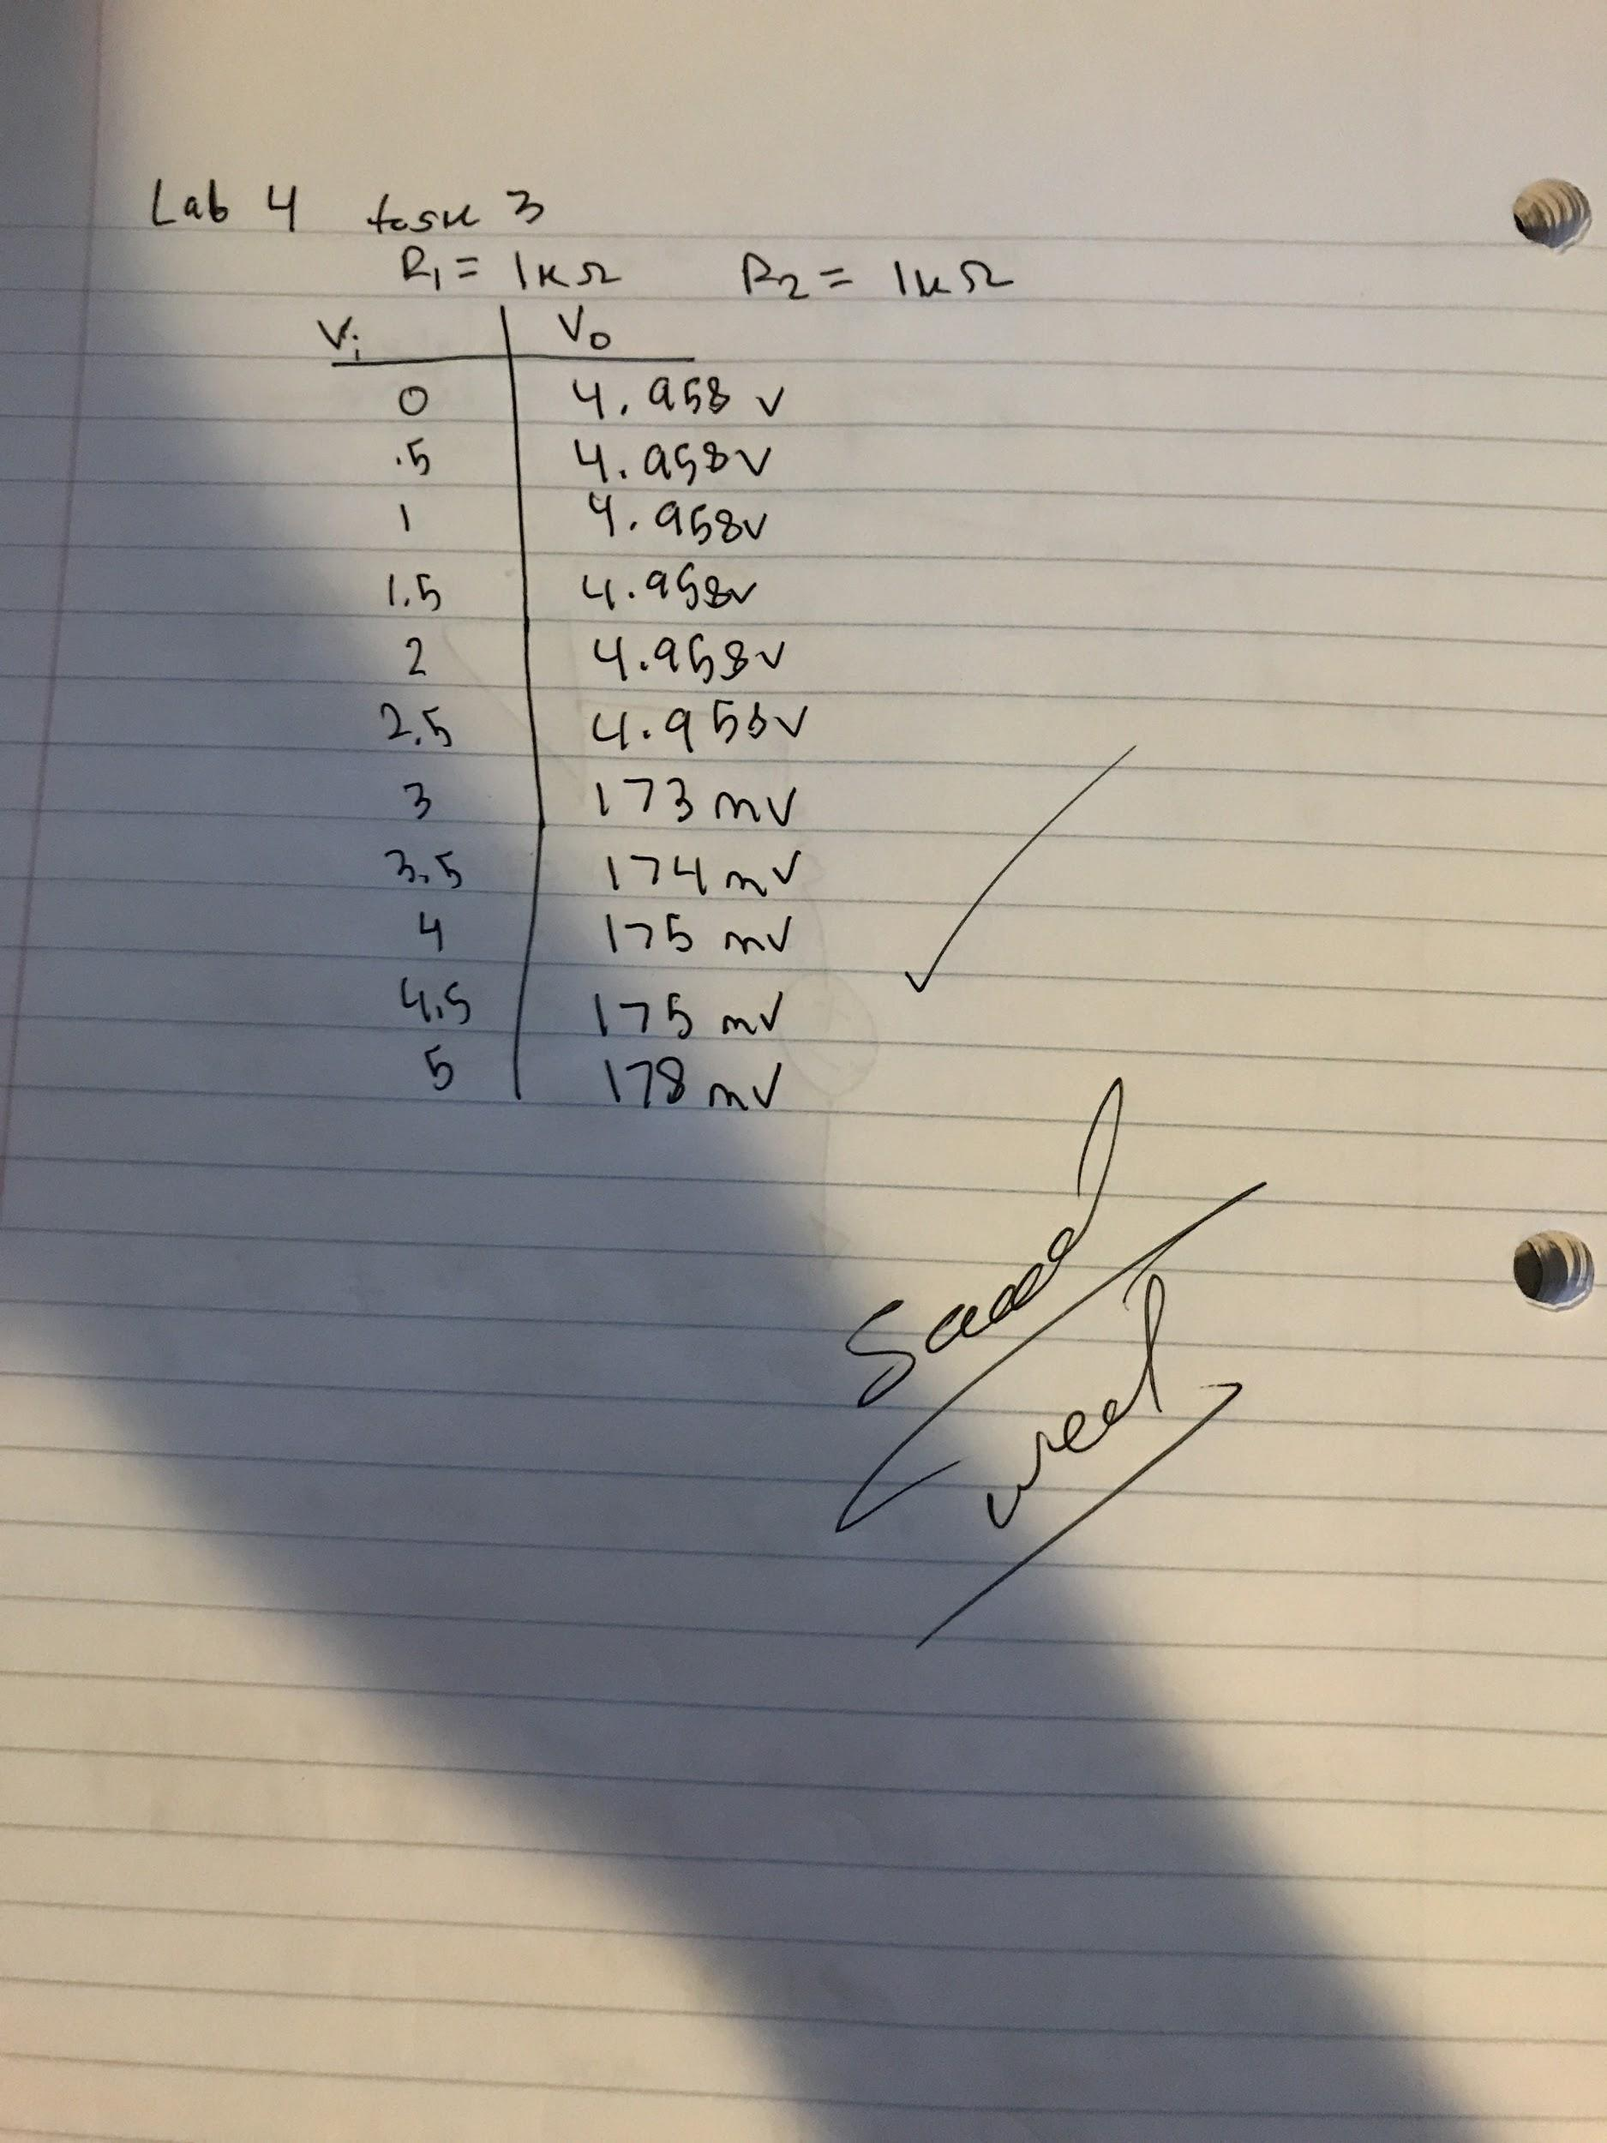

**Conclusion:**

Through this experiment the emitter, photodetector, amplifier, and comparator were built and used to introduce students to each topic. The applications of each of these circuits will be used to create one unit in the next lab. In conclusion this lab was informative and a good way to introduce students to the topics necessary for the next lab.